**Understanding AWS Environment**

* AWS Regions:

Amazon organizes its large server harware in various geographical regions 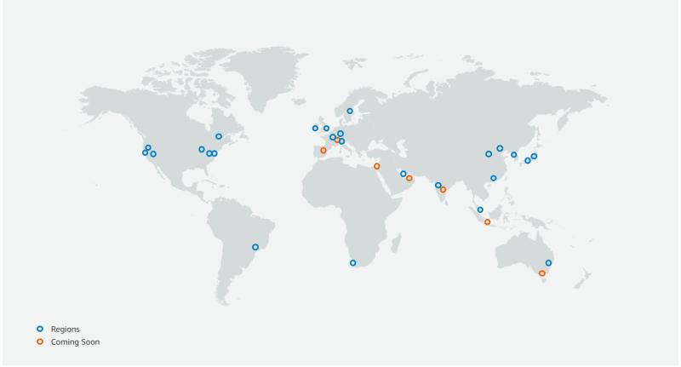Amazon each region has a region code <https://docs.aws.amazon.com/general/latest/gr/rande.html#regional-endpoints> 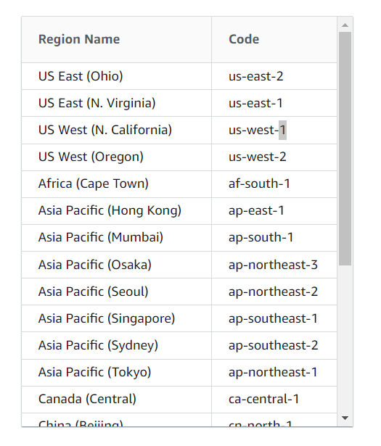

Choosing a Region for creating resources in AWS 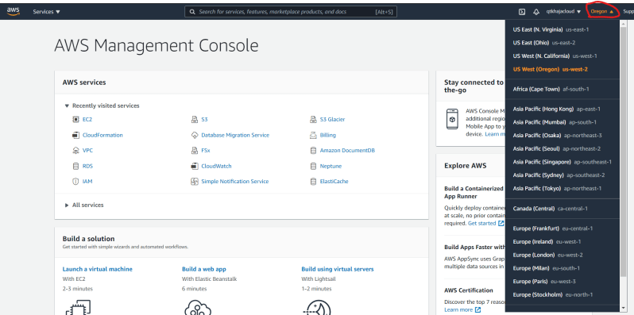

* Availability Zones: 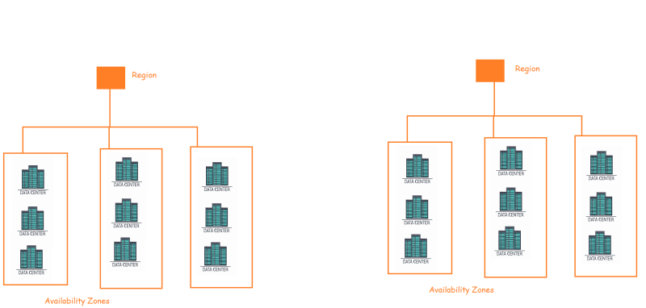

**Working with AWS Resource**

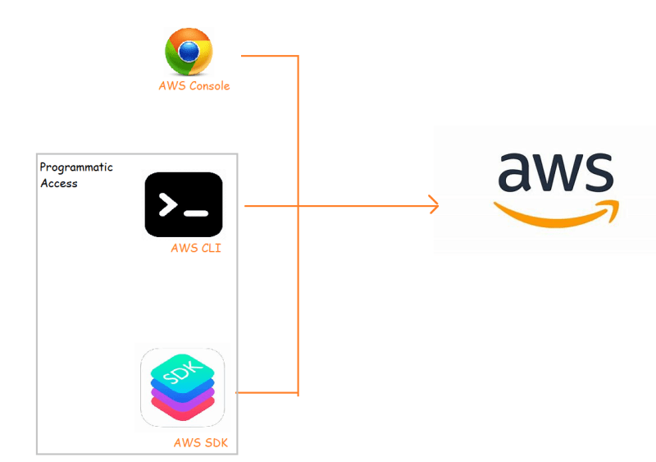

**Exploring AWS Services**

